I will design an application using the crud functionality using Python, Flask, Docker and SQLite for a database.

My application will be a Daily Task Manager where the user can add a task, name the task and delete or update the task if needed. This information will be stored in the SQLite database. Use container instances to create a continuous integration (CI)/continuous deployment (CD) pipeline that will automatically test, build and deploy the application

**Technologies**

Flask in Python This gives me the means to create the app with added functionality such as forms and database interactions.

Python will be used to create the app. The basic breakdown of the application will have template HTML files for the frontend of the app and the programming code (python) will used for the backend of the app on an application folder. Together these will make the web page where the CRUD functionality will incorporated.

In order for a CRUD functionality to work I will also use SQLite for the database. The database must contain two tables with a relationship The relationship must at least be one-to-many.

CI/CD Pipeline will be used to automate the integration and deployment of new code.

Pipeline to be triggered when new code to be pushed onto GitHub repository.

**Deployment**

The application should be deployed to a Docker Swarm hosted in the cloud both should be on the same resource group and use the same virtual network. The Docker Swarm will consist of one manager node and one worker node.

**Management of the project**

The project will be managed on Jira showcasing Estimation, MoSCoW Prioritisation and User Stories.

The Use of Git Bash and GitHub will help store, share and update my repository for this app across the technologies.

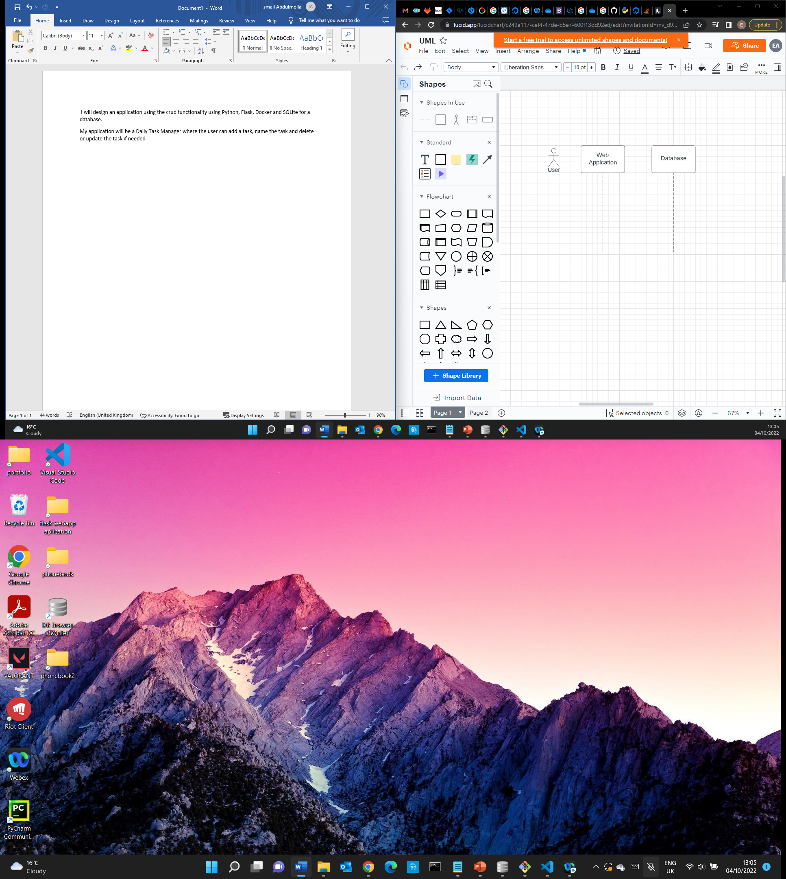

No Task created

Information invalid

(Else)

(If task input is valid)

Alternative

Add new task

Information ok

Information filled

Insert information regarding task